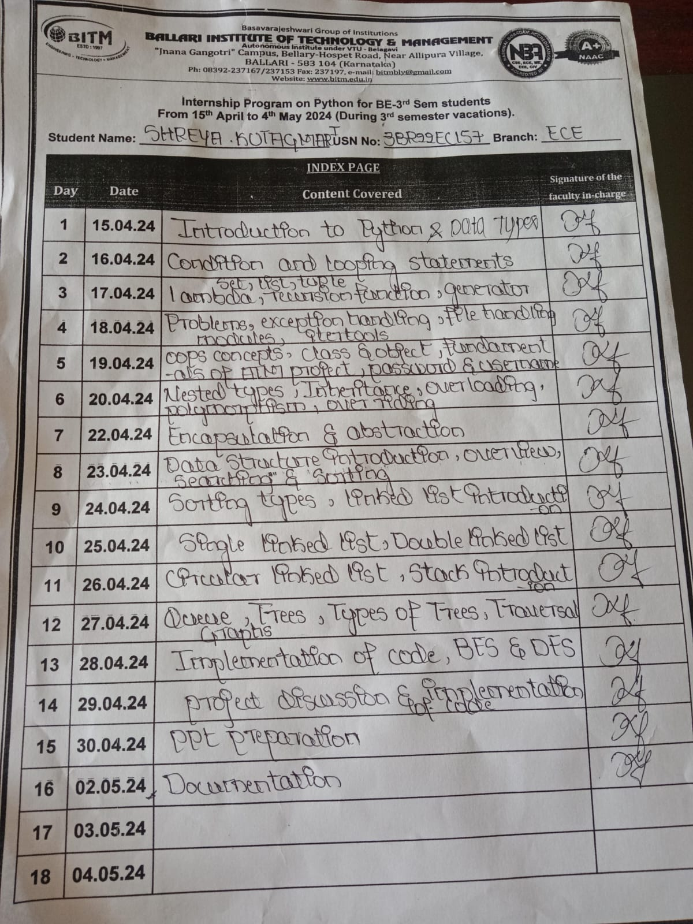

ABSTRACT

* This Python implementation offers a flexible project management system tailored for organizing and tracking project schedules. The system consists of three essential classes: Schedule, Project Timeline, and Project Scheduler, facilitating comprehensive project management functionalities.
* The Schedule class serves as a blueprint for individual tasks within a project, defining attributes such as schedule ID, start date, and end date. It includes methods for updating schedule details, ensuring dynamic adjustment of task timelines.
* The Project Timeline class acts as a container for managing schedules associated with a specific project. It enables seamless addition, removal, and modification of schedules within the project timeline, fostering agile project planning and execution.
* The Project Scheduler class serves as the orchestrator of project timelines, offering a centralized interface for creating, adjusting, and deleting project timelines. By maintaining a dictionary of project timelines, it streamlines project management processes and enhances organizational efficiency.
* The system is equipped with a user-friendly command-line interface (CLI), empowering users to interact with project timelines effortlessly. With options to create, adjust, delete, display, and update schedules, it caters to diverse project management needs, promoting effective collaboration and coordination.
* In summary, this Python project management system provides a robust framework for orchestrating project schedules, fostering collaboration, and maximizing productivity in various organizational settings.

INTRODUCTION OF THE PROJECT

In today's dynamic business environment, effective project management is essential for the success of any organization. Timely execution, resource allocation, and meeting deadlines are crucial aspects of project management that require careful planning and scheduling.

The project scheduling system presented here offers a practical solution to streamline project management processes. By leveraging Python programming, it provides a flexible and user-friendly platform for creating, managing, and monitoring project timelines and schedules.

Key features of the project scheduling system include:

1.Timeline Creation: Users can create project timelines by specifying the project name and end date. This establishes a framework for organizing and tracking project activities.

2.Schedule Management: The system allows users to add, adjust, and update schedules within project timelines. Each schedule is defined by a unique ID, start date, and end date, enabling precise coordination of tasks and resources.

3.Dynamic Adjustments: Project timelines can be dynamically adjusted to accommodate changes in project scope, deadlines, or resource availability. This ensures adaptability and responsiveness to evolving project requirements.

4.User Interaction: Through an intuitive command-line interface, users can easily interact with the scheduling system. The interface provides menu options for performing various tasks, such as adding schedules, deleting timelines, and displaying project details.

5.Error Handling: The system incorporates error handling mechanisms to detect and notify users of invalid inputs or inconsistencies in scheduling operations. This promotes data integrity and reliability in project management.

Overall, the project scheduling system offers a comprehensive solution for efficient project planning and execution. Whether managing small-scale initiatives or complex enterprise projects, this system empowers organizations to optimize their resources and deliver projects on time and within budget.

MODULE DESCRIPTION

The project scheduling system is encapsulated within a Python module, providing a cohesive framework for managing project timelines and schedules. The module consists of several classes and functions, each serving a specific purpose in the project management workflow. Below is a detailed description of each component within the module:

1.Schedule Class:

* **Description:** This class represents an individual schedule within a project timeline. It encapsulates essential attributes such as the schedule ID, start date, and end date.
* **Functionality:** The Schedule class provides methods for updating the start and end dates of a schedule.

2.Project Timeline Class:

* **Description:** The Project Timeline class represents the timeline of a specific project. It contains a collection of schedules and associated project information, including the project name and end date.
* **Functionality:** This class offers methods for adding, removing, updating, and displaying schedules within the project timeline. It also facilitates adjustments to the overall project end date.

3.ProjectScheduler Class:

* **Description:** The Project Scheduler class serves as the central component for managing project timelines and schedules. It orchestrates the creation, deletion, and manipulation of project timelines.
* **Functionality:** This class provides functions for creating project timelines, adding schedules to timelines, adjusting schedule details, deleting timelines, displaying schedules, and updating schedule information.

4.Command-Line Interface (CLI) Functions:

* **Description**: The module includes CLI functions to interact with the project scheduling system via a command-line interface.
* **Functionality**: These functions prompt users to input commands and parameters, allowing them to perform actions such as creating timelines, adding schedules, adjusting dates, deleting timelines, displaying schedules, and updating schedule details.

5.Error Handling Mechanisms:

* **Description**: The module incorporates error handling mechanisms to detect and handle invalid inputs or inconsistencies in scheduling operations.
* **Functionality**: These mechanisms ensure data integrity and reliability by notifying users of errors and preventing unintended actions that could compromise project management tasks.
* Overall, the module provides a comprehensive and extensible solution for project scheduling, empowering users to effectively plan, organize, and execute projects with precision and efficiency.

FLOWCHART

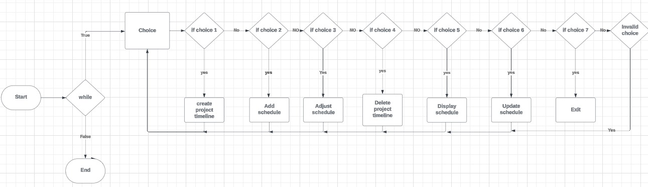

ALGORITHM

1. **Class Definitions**:
   * Define three classes: **Timeline Item**, **Schedule**, and **Project Timeline**.
   * **Timeline Item** represents a generic time interval with start and end dates.
   * **Project Timeline** represents the timeline of a project and contains schedules.
2. **Project Scheduler Class**:
   * Manages project timelines through methods for creating, adjusting, deleting, and displaying timelines.
   * Validates input dates and ensures the project's readiness before creating timelines.
3. **Main Program**:
   * Create a **Project Scheduler** instance.
   * Run a loop to interactively choose operations.
4. **Input Handling**:
   * For each operation, prompt the user for input such as project name, schedule ID, start date, and end date.
   * Validate inputs and execute corresponding methods in the **Project Scheduler** class.
5. **Output Handling**:
   * Provide feedback messages for successful or failed operations.
   * Display schedules with their IDs, start dates, and end dates.
6. **Current Date Simulation**:
   * Simulate the current date for validation purposes.
7. **Exit Condition**:
   * Exit the loop and end the program upon selecting the exit option.

OUTPUT

1.Create Project Timeline

2. Add Schedule

3. Adjust Schedule

4. Delete Project Timeline

5. Display Schedule

6. Update Schedule

7. Exit

Enter your choice: 1

Enter project name: project A

enter end date(YYY-MM-DD):2024-04-29

timeline created

1. Create Project Timeline

2. Add Schedule

3. Adjust Schedule

4. Delete Project Timeline

5. Display Schedule

6. Update Schedule

7. Exit

Enter your choice: 2

Enter project name: project A

Enter schedule ID: 1234

Enter start date (YYYY-MM-DD): 2024-05-09

Enter end date (YYYY-MM-DD): 2024-06-17

Schedule added.

1. Create Project Timeline

2. Add Schedule

3. Adjust Schedule

4. Delete Project Timeline

5. Display Schedule

6. Update Schedule

7. Exit

Enter your choice: 3

Enter project name: project A

Enter schedule ID: 1234

Enter new start date (YYYY-MM-DD): 2024-06-18

Enter new end date (YYYY-MM-DD): 2024-07-08

end date extended

Schedule adjusted.

1. Create Project Timeline

2. Add Schedule

3. Adjust Schedule

4. Delete Project Timeline

5. Display Schedule

6. Update Schedule

7. Exit

Enter your choice: 5

Enter project name: project A

Schedule ID: 1234, Start Date: 2024-06-18, End Date: 2024-07-08

1. Create Project Timeline

2. Add Schedule

3. Adjust Schedule

4. Delete Project Timeline

5. Display Schedule

6. Update Schedule

7. Exit

Enter your choice: 6

Enter project name: project A

Enter schedule ID: 1234

Enter new start date (YYYY-MM-DD): 2024-05-08

Enter new end date (YYYY-MM-DD): 2024-06-18

Schedule updated.

. Create Project Timeline

2. Add Schedule

3. Adjust Schedule

4. Delete Project Timeline

5. Display Schedule

6. Update Schedule

7. Exit

Enter your choice: 7

Exiting...

CONCLUSION

The project scheduling assistant provides essential functionalities for managing project timelines and schedules through a command-line interface.

It ensures data validation, offers informative feedback to users, and can be extended for more complex scheduling needs.

With its simplicity and flexibility, it serves as a solid foundation for efficient project management.

REFERENCES

* Chatgpt
* Google and Pandas
* Visual studio code